S3-BUCKET
TASK : Task on S3
- Create an S3 bucket and upload some objects to S3.

Objective : In a real DevOps environment, S3 is commonly used for application artifacts, backups, logs, configuration files, Terraform state, static files, and CI/CD artifacts.
Prerequisites :
Before creating the bucket make sure we have:
- An active AWS account
- IAM User/Role with S3 permissions
We need permissions such as:
s3:CreateBucket
s3:PutObject
s3:ListBucket
- AWS Console access
- AWS Region
- Globally unique bucket name
- Files to upload

Step 1: Open S3
Log in to the AWS Management Console.
Search for S3.
Open Amazon S3.
Click Create bucket.

Step 2: Configure the bucket
Keep Block all public access enabled unless you specifically need public access.
Keep Bucket Versioning disabled for this basic exercise, or enable it
Click Create bucket.

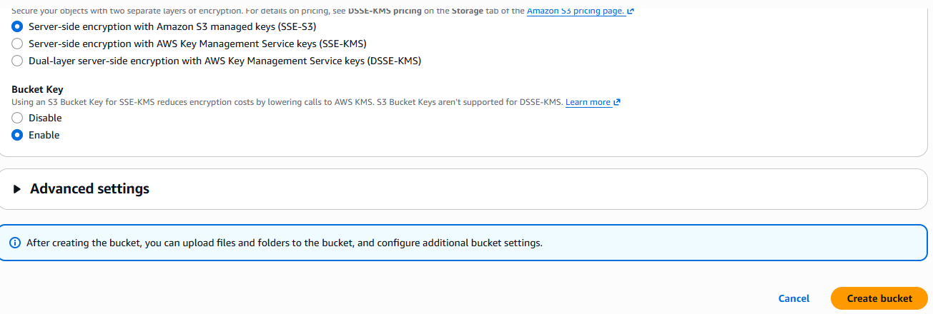
Step 3: Upload an Object
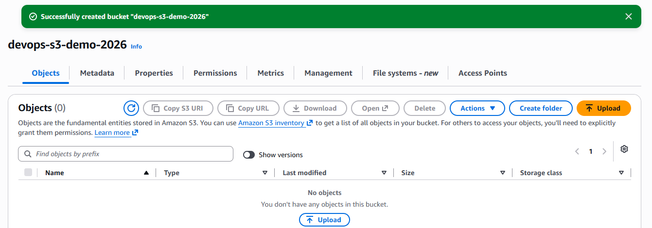

Step 4 : Upload → Add files
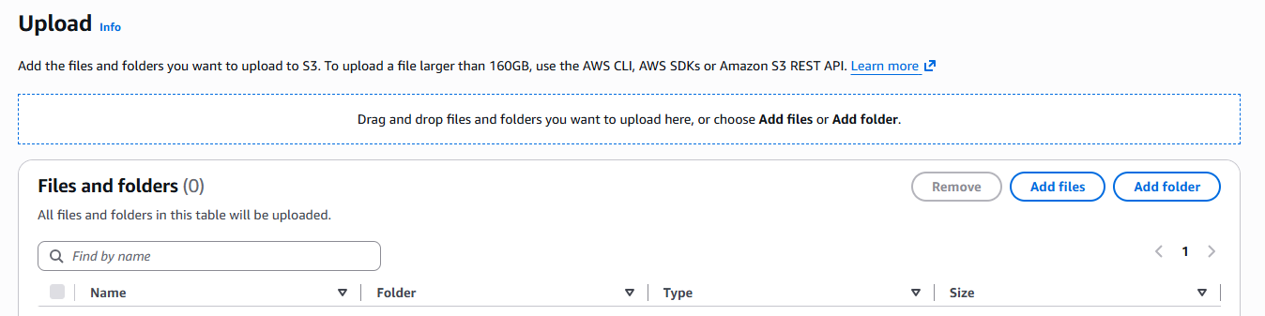
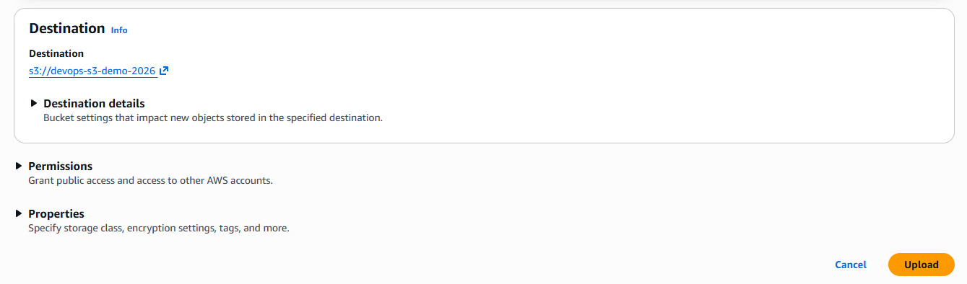
Click Upload.
Screenshot Evidence : Upload succeeded
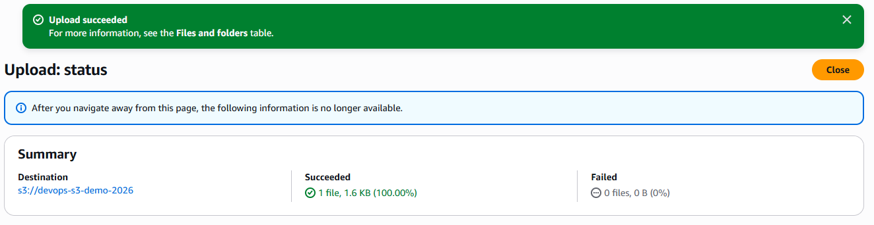

- Deploy a static website in the S3 bucket.

Objective :
The main purpose is to understand how S3 can serve static content without a traditional web server.
This task means hosting a website consisting of HTML, CSS, JavaScript, images, etc. directly from Amazon S3, without running an EC2 web server.

User Browser
|
| HTTP/HTTPS
↓
S3 Website
|
S3 Bucket
|
+--------------+--------------+
| | |
↓ ↓ ↓
index.html style.css app.js
Prerequisites :
Before performing the task, we should have the following.
- We need an AWS account with access to S3.
- IAM identity needs appropriate S3 permissions to:
  - Create the bucket
  - Upload objects
  - Configure the bucket
  - Read objects
- Create a bucket with a unique name.
- Website Files

For ex :
my-static-website-2026-unique/
|
+── index.html
+── error.html
+── style.css
+── images/
Static Website :
A static website serves files as they are stored.
The browser receives the static files directly.

Step 1 : Create a Bucket
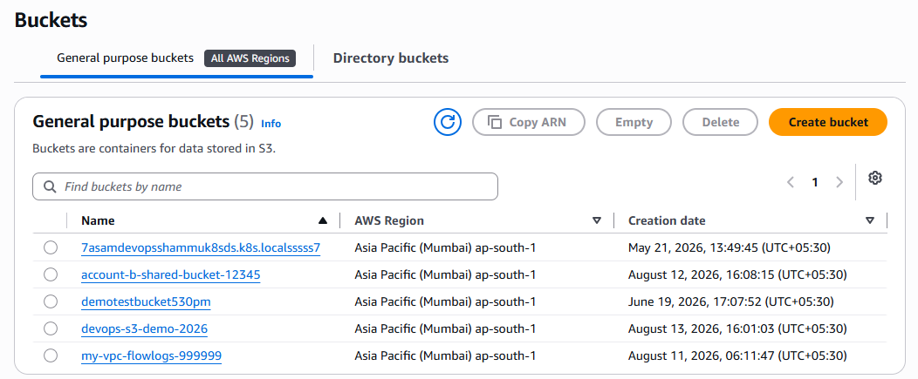
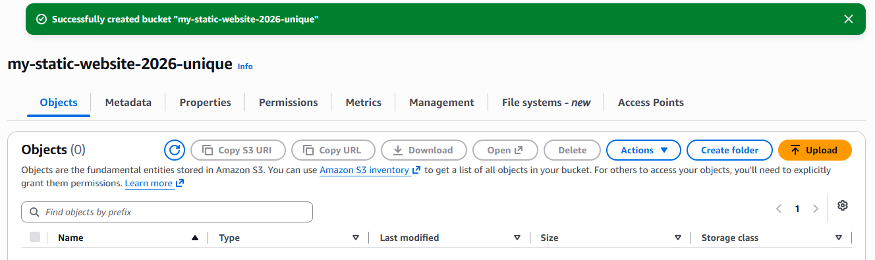

Step 2 : Upload Website Files index.html
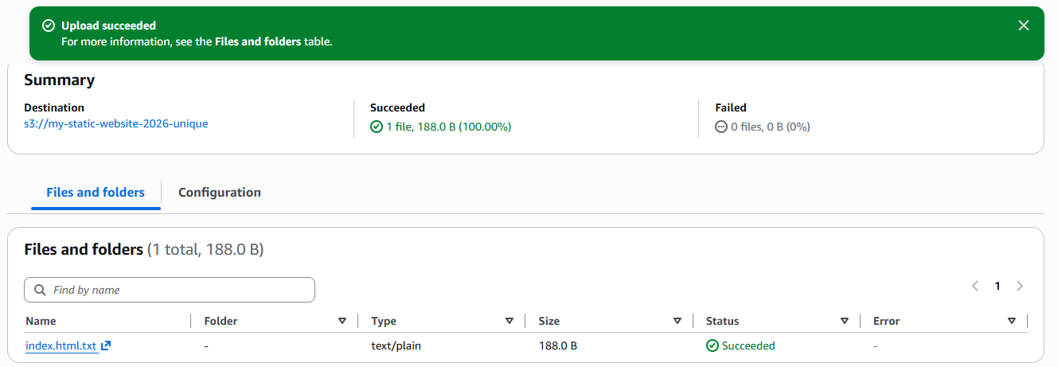
Step 3 : Enable static webhost
S3
↓
Your bucket
↓
Properties
↓
Static website hosting
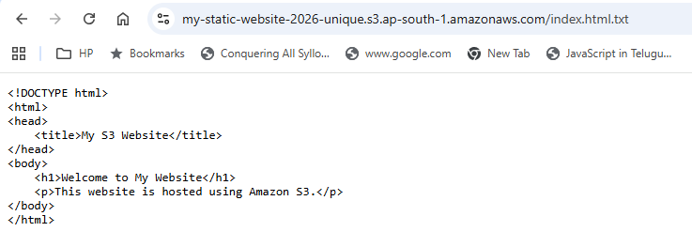

- Enable cross-region replication on S3 buckets.

Objective : The objective is to configure automatic replication of S3 objects from one AWS Region to another Region.

Why do we need Cross-Region Replication?
>> Disaster Recovery
>> Business continuity
>> Compliance
>> Lower latency for global users
>> Backup/data protection

Prerequisites :
Before enabling CRR, make sure you have the following.

Prerequisite 1 : Two S3 buckets

we need

Source Bucket
↓
Region A

Destination Bucket
↓
Region B

Prerequisite 2 : Enable Versioning on both buckets

Source Bucket
↓
Versioning = Enabled

Destination Bucket
↓
Versioning = Enabled

AWS requires versioning to be enabled on both the source and destination buckets for replication.

Prerequisite 3 : IAM permissions
S3 needs permission to read objects from the source bucket and write replicas to the destination bucket.
The replication process uses an IAM service role that Amazon S3 assumes.

Amazon S3
│
│ AssumeRole
▼
S3 Replication IAM Role
│
├── Read source objects
│
└── Write destination objects
When using the AWS Console, AWS can create the required replication role for you. AWS recommends this approach for the console setup.

Prerequisite 4 : IAM user/role configuring replication
The IAM user or role performing the configuration needs permissions to create the replication rule.
When using an existing replication role, the administrator also needs iam:PassRole to pass that role to S3.

Prerequisite 5 : Destination bucket permissions
If both buckets belong to the same AWS account, the setup is simpler.
Account A
│
├── Source Bucket
│
└── Destination Bucket
If the source and destination buckets belong to different AWS accounts, additional permissions are required on the destination bucket.

Prerequisite 6 : KMS considerations
If your objects are encrypted using SSE-KMS, additional KMS permissions are required.
You need to allow the replication role to use the relevant KMS keys.

Complete architecture :
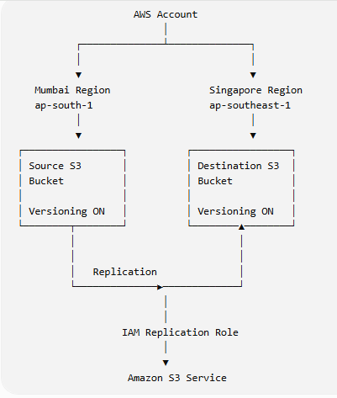

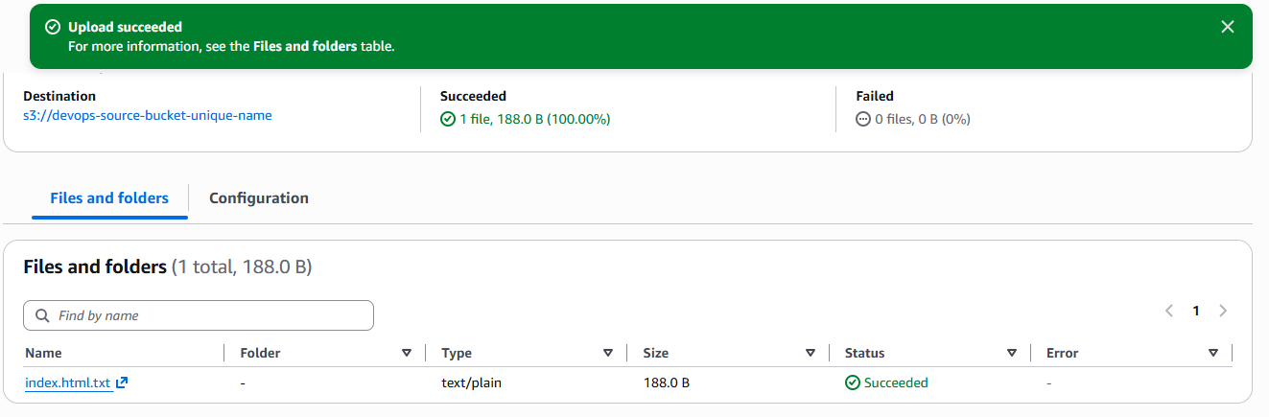
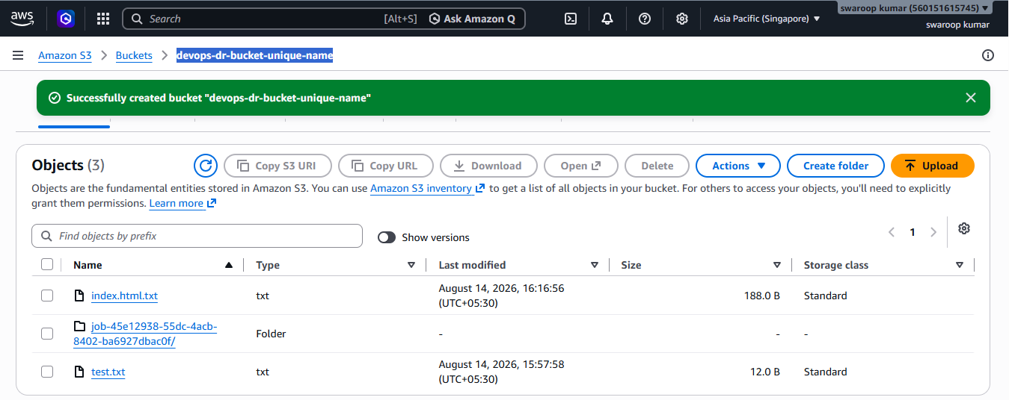

S3 Cross-Region Replication creates a replica of objects in another AWS Region and is commonly used for disaster recovery, compliance, and business continuity. It can complement, but should not automatically be treated as a complete backup strategy.

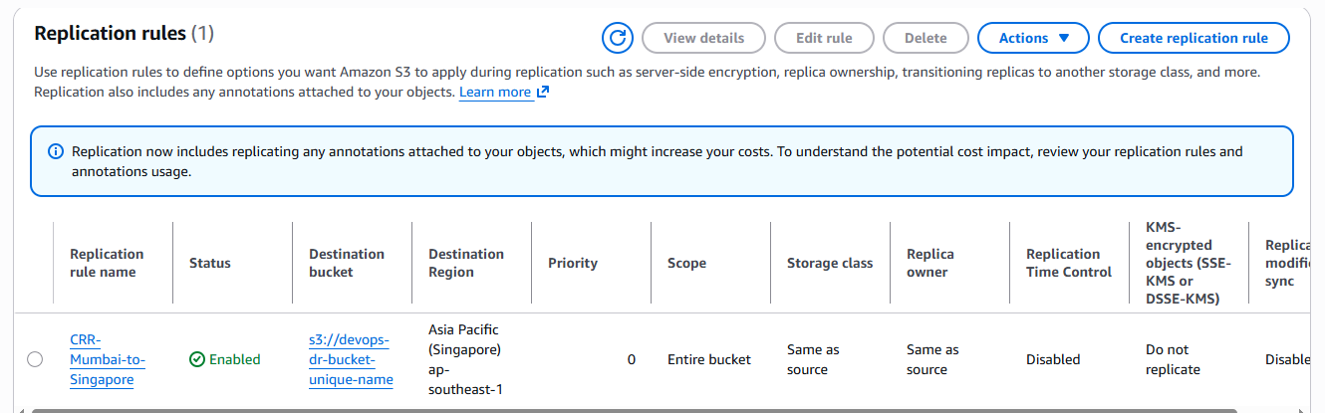

- Configure a bucket policy so only the Admin user can see the objects of the S3 bucket.

Objective
Allow only the IAM user Admin to view/list objects in a specific S3 bucket, while preventing other IAM users from accessing the bucket objects.
Prerequisites :
• AWS account
• S3 bucket already created
• IAM user named Admin
• Admin user has valid credentials
• You know the bucket name

Step 1: Get the Admin User ARN
Go to :
AWS Console → IAM → Users → Admin
Copy the ARN :
arn:aws:iam::560151615745:user/ADMIN

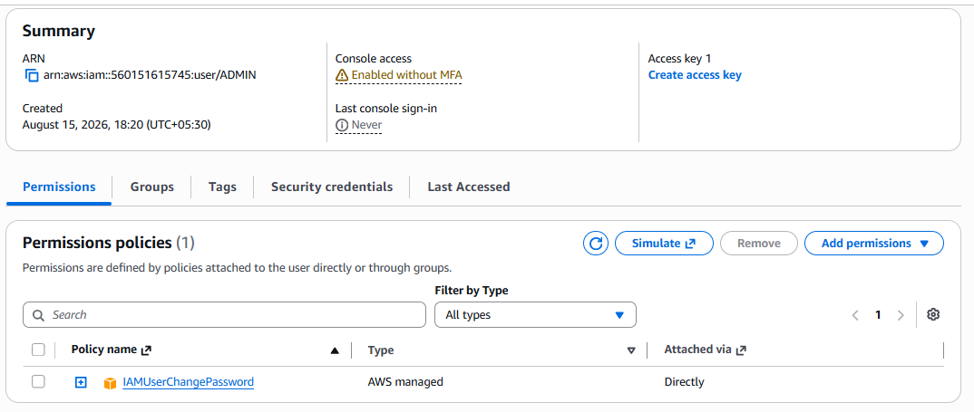

Step 2: Open the S3 Bucket
Go to:
AWS Console → S3 → Your bucket → Permissions → Bucket policy
Click Edit.
Step 3: Add the Bucket Policy
JSON :
{
"Version": "2012-10-17",
"Statement": [
{
"Sid": "AllowAdminListBucket",
"Effect": "Allow",
"Principal": {
"AWS": "arn:aws:iam::123456789012:user/Admin"
},
"Action": "s3:ListBucket",
"Resource": "arn:aws:s3:::YOUR-BUCKET-NAME"
},
{
"Sid": "AllowAdminGetObjects",
"Effect": "Allow",
"Principal": {
"AWS": "arn:aws:iam::123456789012:user/Admin"
},
"Action": "s3:GetObject",
"Resource": "arn:aws:s3:::YOUR-BUCKET-NAME/*"
}
]
}
Click Save changes.
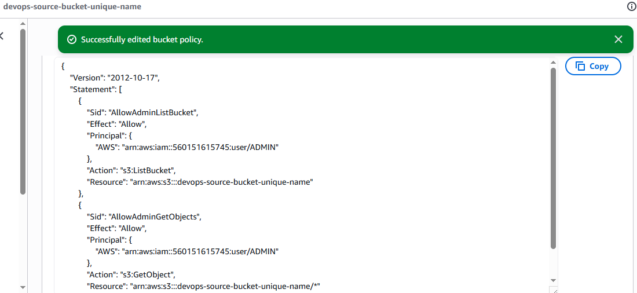

Step 4: Test with Admin
Log in as the Admin user and go to:
S3 → Bucket → Objects
Admin should be able to:
• ✅ List the bucket
• ✅ See objects
• ✅ Download/read objects
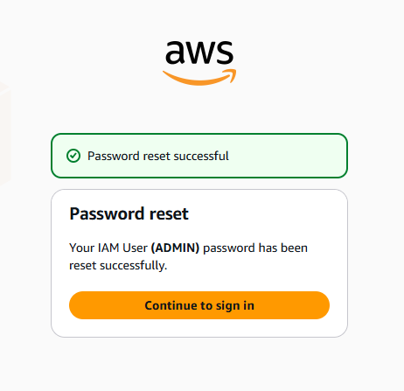

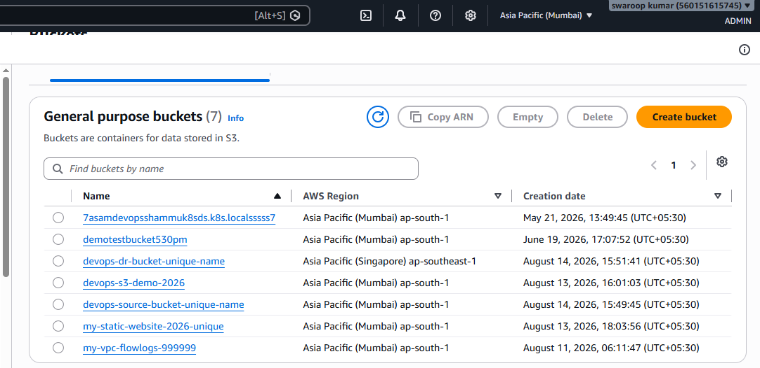
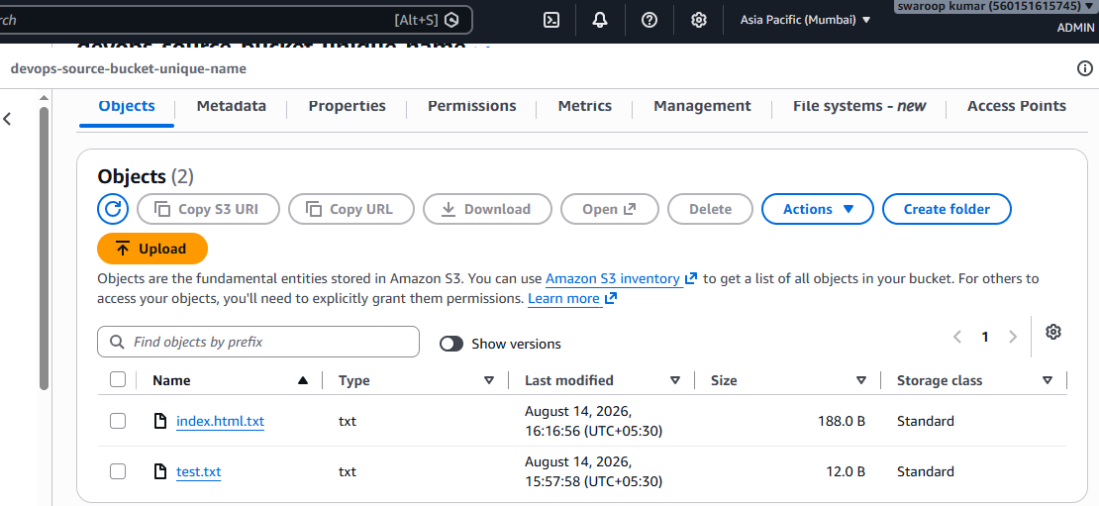

5. Set up lifecycle policies to automatically transition or delete objects based on specific
criteria.
Task : Set Up S3 Lifecycle Policies
Objective :
Configure an S3 Lifecycle Rule to automatically:
• Move objects to a cheaper storage class after a specific number of days.
• Delete objects after a specified period.
• Reduce storage cost and automatically manage old/unwanted data.

Prerequisites : S3 Lifecycle Policy
Before configuring an Amazon S3 Lifecycle Policy to automatically transition or delete objects, make sure you have:
- AWS Account
- S3 Bucket
- Objects in the Bucket
- IAM Permissions
- Define Lifecycle Criteria
- Decide the Scope
- Versioning — if required

Step 1: Open the S3 Bucket

Go to:

AWS Console → S3 → Buckets → Select your bucket

Management → Lifecycle rules → Create lifecycle rule

Step 2: Create Lifecycle Rule

Enter a rule name:

archive-and-delete-old-objects

Choose:

Apply to all objects in the bucket

If you want the rule only for specific objects, you can instead use a prefix or object tag.

Step 3: Configure Transition

Enable:
Transition current versions of objects between storage classes

Add transitions:
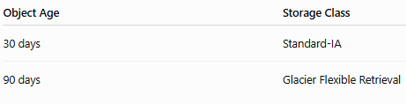
So the lifecycle becomes:

S3 Standard

↓ 30 days

Standard-IA

↓ 60 more days

Glacier Flexible Retrieval
The transition days are generally measured from the object's creation time.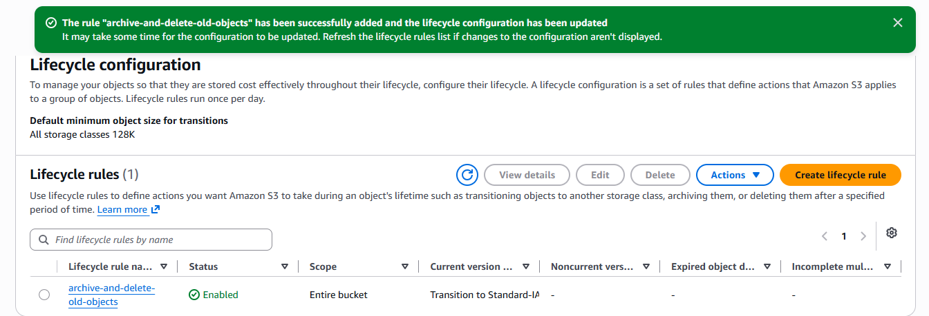

Step 4: Configure Expiration
Enable:

Expire current versions of objects

Set:

Days after object creation: 365

Therefore:

Day 0 → S3 Standard
Day 30 → Standard-IA
Day 90 → Glacier Flexible Retrieval
Day 365 → Object deleted

Click Create rule.

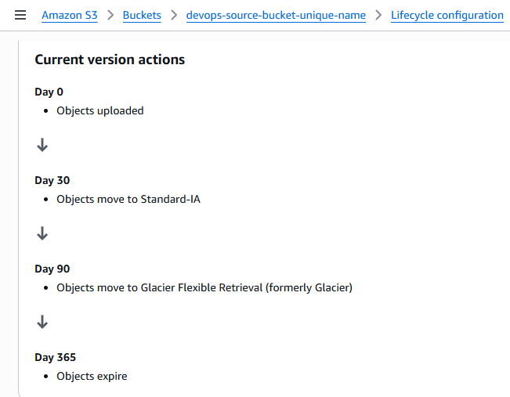
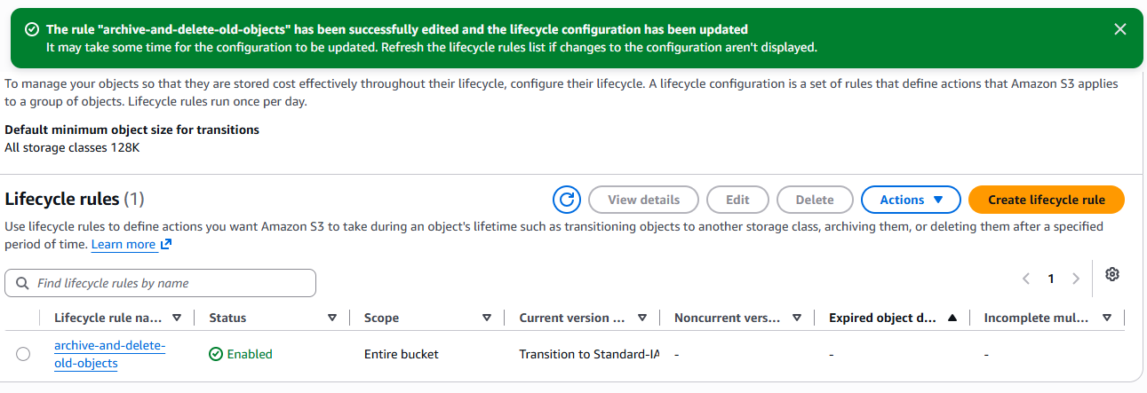

6. Push some objects to S3 using the AWS CLI.
Objective :
Upload files/objects from your local machine to an S3 bucket using the AWS CLI.

Prerequisites :

- AWS CLI installed.
- AWS credentials configured.
- IAM user/role has S3 permissions such as:
• s3:PutObject
• s3:ListBucket (useful for verification)
- S3 bucket already created.
- Bucket name is available.

Step 1: Verify AWS CLI
aws --version
Step 2: Configure AWS CLI
aws configure
AWS Access Key ID: <your-access-key>
AWS Secret Access Key: <your-secret-key>
Default region name: ap-south-1
Default output format: json

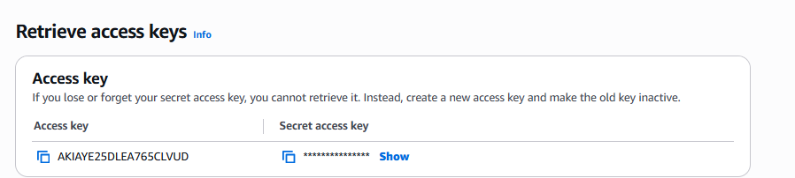
Step 3: Verify AWS Account
Cmd : aws sts get-caller-identity
Step 4: Create Some Test Files
mkdir s3-test
cd s3-test

echo "This is file 1" > file1.txt
echo "This is file 2" > file2.txt
echo "This is file 3" > file3.txt
check :
ls
output :

file1.txt
file2.txt
file3.txt

Step 5: Upload One Object

Cmd :aws s3 cp file1.txt s3://devops-source-bucket-unique-name/

Expected output :

upload: ./file1.txt to s3://devops-source-bucket-unique-name/file1.txt

Step 6: Upload Multiple Objects

Cmd : aws s3 cp . s3://devops-source-bucket-unique-name/ --recursive

Step 7: Verify the Objects

Cmd : aws s3 ls s3://devops-source-bucket-unique-name/

2026-08-15 20:30:10 15 file1.txt
2026-08-15 20:30:12 15 file2.txt
2026-08-15 20:30:15 15 file3.txt
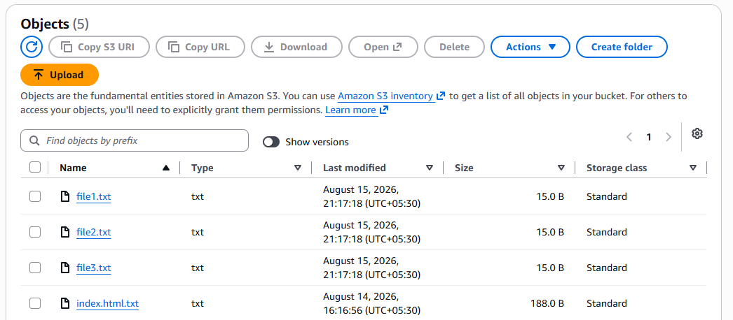
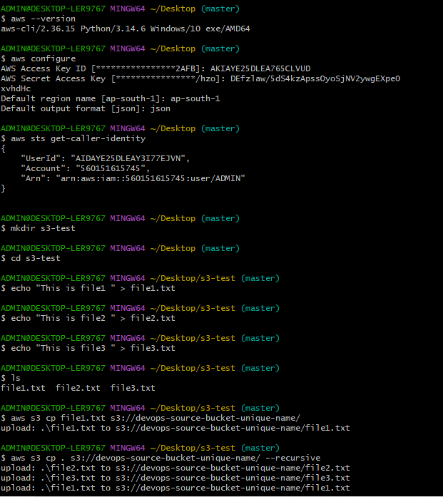
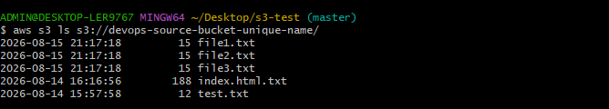
- Write a Bash script to create an S3 bucket.

Objective :
Create an Amazon S3 bucket automatically using a Bash script instead of manually creating it from the AWS Console.

- • Check whether AWS CLI is installed.
- • Verify AWS credentials.
- • Generate a unique bucket name.
- • Create the S3 bucket.
- • Verify that the bucket was created successfully.

Prerequisites :
1. AWS Account
You need an active AWS account.
2. IAM User/Role
The identity running the script must have permission to create S3 buckets.

AWS Console → IAM → Users → ADMIN → Permissions → Add permissions → Create inline policy

{
"Version": "2012-10-17",
"Statement": [
{
"Effect": "Allow",
"Action": "s3:CreateBucket",
"Resource": "*"
}
]
}

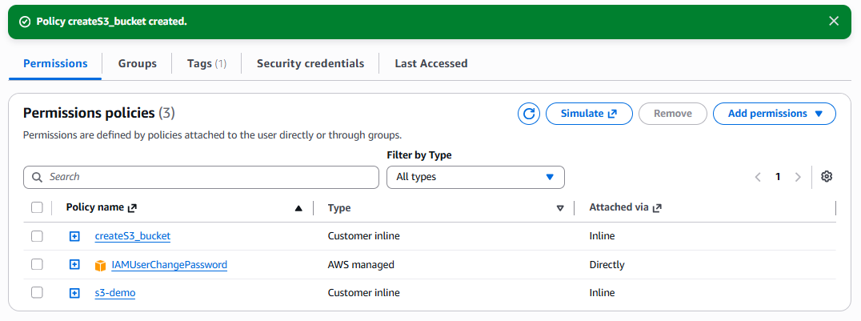

Step 1 :
AWS CLI Installed
Check :
Cmd aws –version

Step2 : Configure AWS Credentials
Cmd : aws configure

AWS Access Key ID: <your-access-key>
AWS Secret Access Key: <your-secret-key>
Default region name: ap-south-1
Default output format: json
Cmd : aws sts get-caller-identity
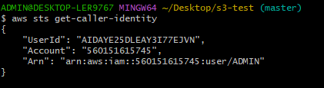
Step 3 :
vi create_s3_bucket.sh
chmod +x create_s3_bucket.sh
./create_s3_bucket.sh
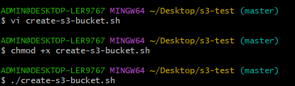
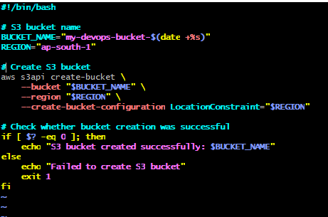

Step 4 : verify bucket
Cmd : aws s3 ls
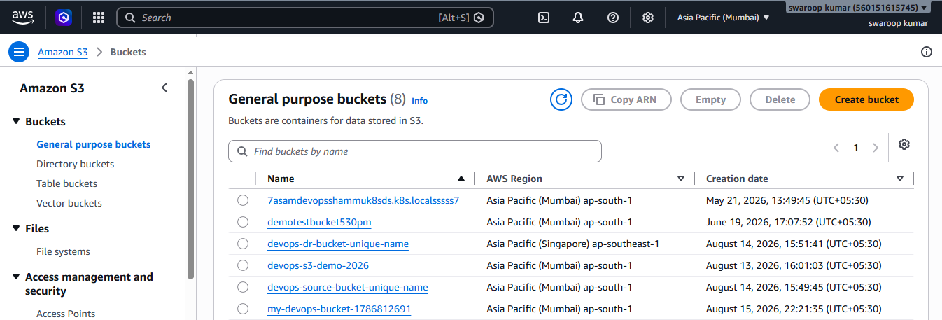
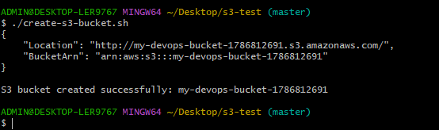
- Upload a 1 GB file to S3 using the CLI
Objective : Upload a 1 GB file from a Linux/EC2 server or local machine to an Amazon S3 bucket using the AWS CLI.
For a 1 GB file, the AWS CLI can handle the upload automatically. For larger files, AWS CLI can use multipart upload.

Prerequisties :
1. AWS CLI Installed
2. AWS Credentials Configured
3. S3 Bucket
4. IAM Permission
s3:PutObject
{
"Version": "2012-10-17",
"Statement": [
{
"Effect": "Allow",
"Action": "s3:PutObject",
"Resource": "arn:aws:s3:::my-devops-bucket-123456/*"
}
]
}
Step 1: Go to Your Working Directory
cd ~/Desktop/s3-test

Step 2: Create a 1 GB File
Since you're using Git Bash on Windows, use the Windows fsutil command:
cmd //c "fsutil file createnew bigfile.img 1073741824"

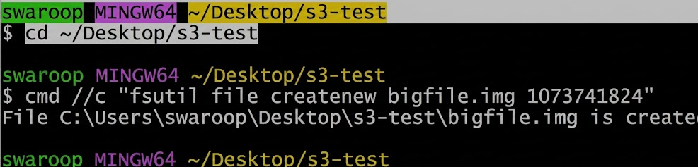

Step 3: Verify the File Size
ls -lh
Expected:
-rw-r--r-- 1 swaroop 1.0G Jul 24 16:30 bigfile.img

Or check only that file:
ls -lh bigfile.img
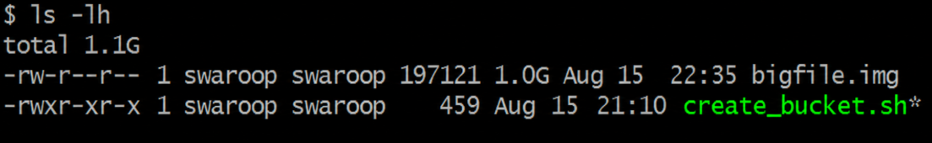

Step 4: Find Your Bucket Name
List your buckets:
aws s3 ls
Example:
2026-08-15 22:35:15 swaroop-demo-1753372000
We'll use:
swaroop-demo-1753372000
Replace it with your actual bucket name in the next command

Step 5: Upload the File
aws s3 cp bigfile.img s3://YOUR-BUCKET-NAME/
Example:
aws s3 cp bigfile.img s3://narayana-demo-1753372000/
Expected output:
Completed 1.0 GiB/1.0 GiB (25.4 MiB/s) with 1 file(s) remaining
upload: ./bigfile.img to s3://swaroop-demo-1753372000/bigfile.img
